**AudioEffects Module Description Document**

**1.Introduction**

Sound effect processing is the specific processing of PCM data in the time domain or frequency domain to achieve a certain effect.

Currently supported sound effects include: MV BASS, MV 3D, Pitch Shifter, Echo, Reverb, EQ, and DRC. These sound effects can be used with ACPWorkbench to control the listening experience on the DU361 platform.

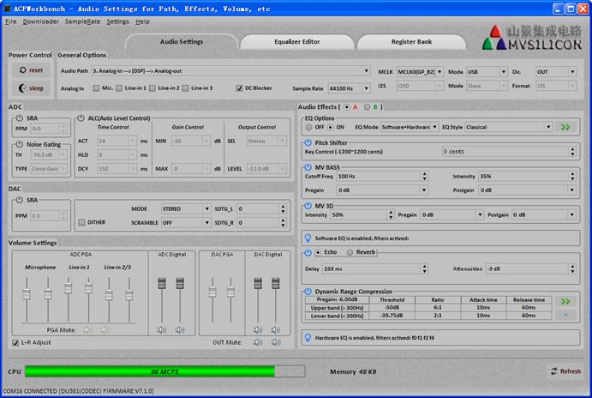

Figure 1. DU361 CODEC Control Platform ACPWorkbench

**2.Main Features**

**2.1.MV BASS**

MV BASS is a virtual bass enhancement technology specially designed to address the insufficient extension when speakers play low-frequency signals. This technology effectively utilizes the principle of "fundamental frequency absence" in psychoacoustics, that is, the human ear can sense the fundamental frequency through a series of harmonics, even if the fundamental frequency part is already missing. This technology, through complex algorithms, shifts the energy in the low-frequency band to the multiplier, and uses precisely calculated harmonic components to reconstruct the bass listening experience. This fills the listener's ears and brain with the low-frequency parts lost due to physical frequency response limitations, thereby significantly enhancing the low-frequency performance of the entire speaker system. All of this does not rely on increasing the size of the speaker or the power of the amplifier.

**2.2.  MV 3D**

The MV 3D algorithm is suitable for application in Sound-bar, desktop speakers, etc., and can be customized into cinema Sound effect mode in combination with other sound effects. Its features include:

* Supports adjustable depth parameters;
* Suitable for stereo sound systems;

**2.3.  Pitch Shifter**

Pitch Shifter is an audio effect that raises or lowers the pitch of an audio signal through a preset value. It supports modulation semitone step size control, with a control range of -1200 to 1200 cents, where one semitone equals 100 cents.

**2.4.  Echo**

Echo is the effect of overlaying previous audio signals onto the currently playing audio signal, creating the impression of echoes in a large spatial environment. Its main features include:

* Adjustable echo depth
* Adjustable echo intensity

**2.5.  Reverb**

When sound waves propagate indoors, they are reflected by obstacles such as walls, ceilings and floors. Each time they are reflected, some of them are absorbed by the obstacles. In this way, when the sound source stops emitting sound, the sound waves have to go through multiple reflections and absorption in the room before finally disappearing. We then feel that the sound continues for a period of time after the sound source stops emitting sound. This phenomenon is called Reverberation (Reverberation, abbreviated as Reverb), and the period of time during this time is called the reverberation time.

The recommended parameter configuration for Reverb is shown in the following table.

|  |  |  |  |  |  |
| --- | --- | --- | --- | --- | --- |
| Mode | Dry | Wet | Width | Room Size | Damping |
| Light mixing, primarily for polishing | 75 | 75 | 100 | 50 | 50 |
| Medium mixing, with noticeable effects | 50 | 125 | 100 | 50 | 50 |
| Full mixing, standard room | 0 | 190 | 100 | 50 | 50 |
| Full mixing, hall | 0 | 160 | 100 | 80 | 50 |

Table 1. Reverb Recommended Parameter Configuration

**2.6.  EQ**

Refer to the EQ module user manual for instructions

**2.7.  DRC**

DRC(Dynamic Range Compression) refers to the situation where, under the condition of a set threshold, when the audio signal exceeds the threshold, DRC compresses the audio signal by amplitude according to the set ratio. It should be used to limit the output amplitude when there is a strong signal to prevent distortion and protect the audio unit. The following figure is a simple illustration of the working principle of DRC.

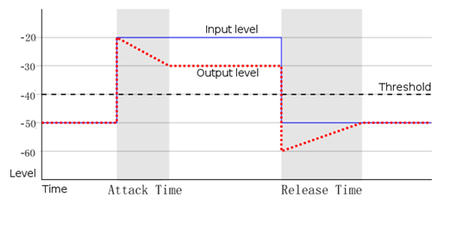

Figure 2. DRC Working Principle

1. **Instructions for Use**

The usage methods of all the sound effect sub-modules are basically the same, as shown below.

1. Initialize the sound effect sub-module and set the sound effect parameters properly
2. Obtain the PCM data of one frame length and call the sound effect sub-module processing API function for processing

1 #include "virtual_bass.h"

 2

 3 **void** AudioEffectProcess(**void**)

 4 {

 5     **if**(VB_ERROR_OK == init_vb(...))

 6     {

 7         **while**(1)

 8         {

 9             **if**(pcm_samples_avariable() >= SAMPLES_PER_FRAME)

 10             {

 11                 apply_vb(...);

 12

 13                 //Get the processed data

 14                 //TODO

 15             }

 16         }

 17     }

 18 }

 19